**Project Initialization and Planning Phase**

| Date | 24 April 2024 |
| --- | --- |
| Team ID | team-739848 |
| Project Name | Identifying Airline Passenger Satisfaction Using Machine Learning |
| Maximum Marks | 3 Marks |

**Problem Statement (Identifying Airline Passenger Satisfaction):**

Many airline passengers aren't as satisfied as they could be. Issues like flight delays, uncomfortable seats,

unclear communication, and high costs often leave travelers feeling frustrated. Improving overall satisfaction requires airlines to better understand and address these concerns to enhance the travel experience.

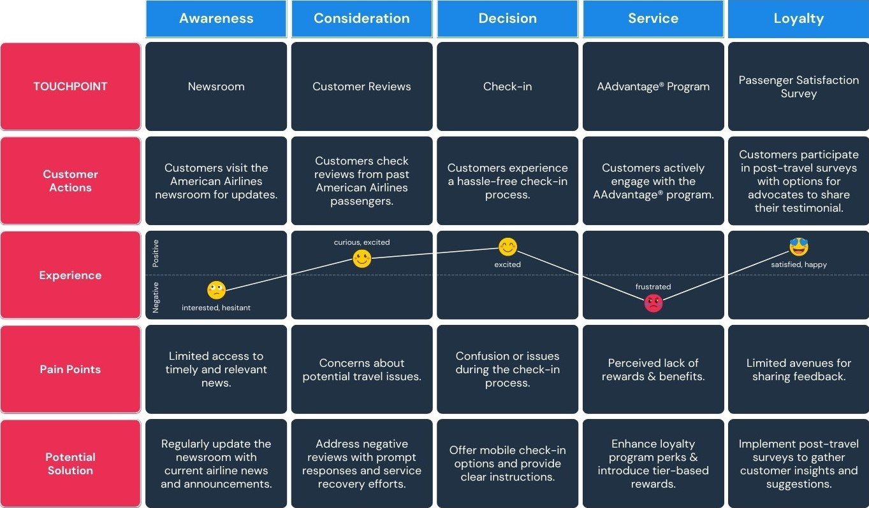

Example:



|  |  |  |  |  |  |
| --- | --- | --- | --- | --- | --- |
| **Passenger List** | **I am**  **(a Passenger)** | **I’m trying to** | **But** | **Because** | **Which makes me feel** |
| PS-1 | Moving to Delhi on business work | Cancel my tickets because my work got cancelled | Ticket cancellation site is not getting open | Technology problem in airline ticket cancellation portal | It made me feel bad because I lost my ticket money |
| PS-2 | Moving to America | Transfer all my things from India to America | My things got damaged | Negligence of ground staff in Airline | It made me feel worse because I need purchase new things |